

FACULTY OF COMPUTING AND INFORMATION MANAGEMENT

BACHELOR OF INFORMATION TECHNOLOGY

**LIVESTOCARE HUB SYSTEM**

**Name**: ***CLIFORD KARIMI MURIUKI***

**ADM.N.O: 20/04226**

**Course: BACHELOR OF SCIENCE (information Technology)**

**UNIT:** **BIT 3105 PROJECT PROGRAMMING**

**SUPERVISOR: JUSTUS MUTIA**

# 

# Project Proposal

Contents

Project Proposal 1

Background 3

Problem Statement 4

Proposed Solution 4

Objectives 5

Justification 6

Scope 7

**Objectives:** 7

**Deliverables:** 7

**Requirements:** 7

**Stakeholder Expectations:** 7

Introduction: 8

Existing systems 9

CHIPSAFER 9

CASE STUDY (Enhancing Livestock Management with a Livestock Monitoring System) 9

Requirement Collection 12

**1. Stakeholder Identification:** 12

**2. Requirement Gathering Techniques:** 13

**3. Functional Requirements:** 13

**Real-time Health Monitoring:** 13

**GPS Tracking and Geofencing:** 13

**Livestock Identification and Data Management:** 13

**Integration with Veterinary Services:** 13

**User Interface and Accessibility:** 13

**4. Non-functional Requirements:** 14

**Performance:** 14

**Reliability:** 14

***Security:*** 14

**Scalability:** 14

**5.** Requirements Prioritization: 14

**6.** Requirement Documentation: 14

Development Methodology 15

**1.** Requirement Analysis: 15

**2.** System Design: 15

3. Prototype Development**:** 15

**4.** Full-Scale Development: 15

**5.** Hardware Integration: 16

**6.** Software Development: 16

**7.** Quality Assurance and Testing: 16

**8.** Deployment and Implementation: 16

**9.** Monitoring and Evaluation: 16

**10.** Documentation and Knowledge Sharing: 17

RESOURCES 17

HADWARE RESOURCES 17

SOFWARE RESOURCES 19

PROJECT MANAGEMENT RESOURCES 20

TRAINING RESOURCES 21

BUDGET 22

PROJECT SCHEDULE 24

PROJECT RISK AND MITIGATION 26

INTRODUCTION

Livestock farming plays a crucial role in Kenya's agricultural sector, contributing significantly to the livelihoods of millions of people. However, farmers face numerous challenges in managing their livestock effectively, including limited access to veterinary services, livestock theft, disease outbreaks, and inefficient resource management.

# **Background**

**For instance, in rural areas, farmers often struggle to access timely veterinary care due to factors such as distance, lack of transportation, and limited infrastructure. This results in delayed interventions, higher veterinary costs, and increased livestock mortality rates. Additionally, livestock theft is a big concern, leading to financial losses and livelihood insecurity among farmers. Moreover, disease outbreaks, caused by factors such as climate variability and poor hygiene practices, pose significant risks to livestock health and productivity.**

**Inefficient resource management practices further compound these challenges, with farmers struggling to optimize feed, water, and medication allocation. This not only impacts farm profitability but also contributes to environmental degradation.**

# **Problem Statement**

Specific problem statement for the Livestock Monitoring System in Kenya could be framed around the challenge of limited access to timely veterinary care and theft in rural areas

"In most rural regions of Kenya, farmers often face significant barriers in accessing timely veterinary care for their livestock. Factors such as long distances to veterinary clinics, lack of transportation infrastructure, and limited availability of veterinary services contribute to delayed interventions and increased livestock mortality rates. As a result, farmers struggle to effectively manage and address health issues in their livestock, leading to higher veterinary costs and reduced farm productivity. This highlights the urgent need for a solution that provides farmers with real-time monitoring capabilities and early disease detection mechanisms, empowering them to take proactive measures to safeguard the health and well-being of their livestock. Additionally, livestock theft is a prevalent concern, leading to financial losses and livelihood insecurity among farmers."

# **Proposed Solution**

The proposed solution aims to address the challenge of limited access to timely veterinary care for livestock and theft in rural regions of Kenya. Leveraging advancements in technology the Livestock system will provide farmers with real-time monitoring capabilities and early disease detection mechanisms, empowering them to take proactive measures to safeguard the health and well-being of their livestock. The integration of GPS tracking functionality (This feature enables farmers to track the location and movements of their livestock in real-time), will provide an effective deterrent against theft and facilitating quick recovery in the event of theft. Additionally, GPS tracking can enhance overall farm security by allowing farmers to monitor grazing patterns, identify potential hazards or risks, and ensure the safety of their livestock.

# **Objectives**

The Livestock Monitoring System aims to address the challenges of limited access to timely veterinary care and livestock theft in rural regions of Kenya. The primary objective is to improve the health and security of livestock by providing farmers with real-time monitoring capabilities.

The keys components would be:

1. **Real-Time Health Monitoring**

The system will integrate sensors and IoT devices to continuously monitor vital health parameters of livestock, including body temperature, heart rate, and activity levels. This real-time monitoring will enable farmers to detect signs of illness or distress early on.

1. **GPS Tracking and Geofencing**

GPS tracking devices will be embedded in livestock collars or tags to monitor the location and movement of individual animals in real-time. Geofencing technology will define virtual boundaries around grazing areas or farm premises, triggering alerts if livestock stray outside designated areas

1. **Alert System and Remote Monitoring**

Farmers will receive instant alerts via mobile application in case of abnormal health conditions or potential security threats.

1. **Integration with Veterinary Services**

The system will facilitate communication and collaboration with veterinary services, allowing farmers to share real-time monitoring data and seek expert advice remotely

# **Justification**

1. **Addressing Critical Health Needs:**

Livestock play a crucial role in the livelihoods of farmers in rural regions of Kenya, providing, income, and security. However, the lack of timely access to veterinary care poses a significant challenge, leading to increased mortality rates, higher veterinary costs, and reduced productivity. Implementing the Livestock Monitoring System is essential to address these critical health needs by providing farmers with real-time monitoring capabilities and early disease detection mechanisms. With continuous monitoring of vital health parameters, farmers can detect signs of illness early on and take measures to safeguard the health livestock, thereby reducing the dependency on veterinary services and mitigating the impact of disease outbreaks.

1. **Enhancing Farm Security:**

Livestock theft is a prevalent concern in rural areas of Kenya, resulting financial losses and livelihood insecurity for farmers. The Livestock Monitoring System offers an effective solution to enhance farm security and reduce the incidence of livestock theft

1. **Empowering Farmers with Technology:**

The implementation of the Livestock Monitoring System represents a significant opportunity to empower farmers with technology-driven solutions that enhance their capacity to manage and protect their livestock effectively. By providing farmers with access to real-time monitoring data the system enables them to make informed decisions and take timely actions to optimize livestock health, security, and productivity. This empowerment of farmers with technology will fosters resilience, innovation, and sustainability in the agriculture sector,

# **Scope**

## **Objectives:**

* Develop and implement a comprehensive Livestock Monitoring System to address the challenges of limited access to timely veterinary care and livestock theft faced by farmers in rural regions of Kenya
* Enhance livestock health, security, and productivity through real-time monitoring, early disease detection, and enhanced farm security measures.

## **Deliverables:**

1. Design and development of the Livestock Monitoring System software and hardware components.
2. Installation and deployment of sensors, IoT devices, and GPS tracking technology on participating farms.
3. Implementation of a user-friendly dashboard and mobile application for farmers to access monitoring data, receive alerts, and manage their livestock remotely.
4. Integration with veterinary services to facilitate remote consultations, expert assistance, and timely intervention for livestock health issues.

## **Requirements:**

* Functional requirements: The system must accurately monitor and report livestock health parameters, track livestock locations in real-time, and provide timely alerts to farmers.
* Non-functional requirements: The system must be user-friendly, reliable, and secure, with minimal downtime and high availability for farmers.
* Integration requirements: Seamless integration with veterinary services is required to facilitate remote consultations and support for livestock health issues.

## **Stakeholder Expectations:**

* Farmers: Stakeholders expect the system to improve livestock health outcomes, enhance farm security, and provide a user-friendly interface for easy management.
* Veterinary Services: Stakeholders expect seamless integration with veterinary services to facilitate remote consultations, support, and expert assistance for livestock health issues.

LITERATURE REVIEW

# Introduction:

Livestock farming plays a crucial role in global food security and rural economies, particularly in regions like Kenya where agriculture is a primary livelihood. However, challenges such as limited access to veterinary care and livestock theft pose significant threats to the health, security, and productivity of livestock. This literature review explores existing research and developments in Livestock Monitoring Systems (LMS) to address these challenges and improve the management and welfare of livestock.

1. **Importance of Livestock Monitoring**

Livestock monitoring is essential for early detection of health issues, prevention of diseases, and optimization of production efficiency.

1. **Technological Solutions**

Recent advancements in technology, such as Internet of Things (IoT), GPS tracking, and sensor networks, have enabled the development of sophisticated monitoring systems.

1. **Integration with Veterinary Services**

Seamless integration with veterinary services is critical for timely diagnosis, treatment, and management of livestock health issues.

1. **Farm Security Measures:**

Livestock theft is a significant concern for farmers, leading to financial losses and livelihood insecurity. “You can tell a lot about an animal through geolocation and movement,” says Victoria Alonsoperez, Chipsafer founder and CEO

# Existing systems

According to my research on existing monitoring system I found monitoring system that help cope with theft of livestock called Chip safer.

## CHIPSAFER

Chipsafer, uses a remote tracking system to identify and geolocate individual livestock, offering security against theft and disease, and demonstrating a growing trend toward the Internet of Things in agriculture.

This a link to an article that described how the system worked on coping cattle rustling (<https://qz.com/africa/1197484/climate-change-kenya-cattle-theft-tackled-with-remote-tracking-chip-technology>).

# CASE STUDY (**Enhancing Livestock Management with a Livestock Monitoring System)**

1. **Background:**

David is a smallholder farmer in rural Kenya, relying on livestock farming as his primary source of income and livelihood. Like many farmers in his community, David faces challenges such as limited access to veterinary care, livestock theft, and unpredictable weather conditions. Concerned about the health and security of his livestock, David seeks a solution that can help him monitor his animals effectively and mitigate these challenges.

1. **Implementation of the Livestock Monitoring System:**

David decides to implement a Livestock Monitoring System (LMS) on his farm to address these challenges and improve his livestock management practices. With the assistance of a local agricultural extension officer, David installs GPS tracking collars and sensors on his livestock and sets up the monitoring system on his smartphone.

1. **Real-time Monitoring and Health Alerts:**

The LMS continuously monitors vital health parameters of David's livestock, including body temperature, heart rate, and activity levels. Whenever there is a deviation from normal patterns or signs of illness detected, the system sends instant alerts to David's smartphone, allowing him to take prompt action and seek veterinary assistance if needed.

1. **Farm Security and Theft Prevention:**

In addition to health monitoring, the LMS includes geofencing functionality to define virtual boundaries around David's farm. If any of his livestock stray beyond the designated boundaries, the system triggers an alert, notifying David of potential unauthorized movement or theft.

1. **Integration with Veterinary Services:**

The LMS also facilitates seamless integration with local veterinary services, enabling David to access remote consultations and expert advice from veterinary professionals. In case of any health concerns or emergencies, David can connect with a vet through the system and receive guidance on diagnosis, treatment, and management of his livestock's health issues. This remote access to veterinary services saves David time and resources, as he no longer needs to travel long distances to seek veterinary care.

1. **Results and Benefits:**

Since implementing the Livestock Monitoring System on his farm, David has experienced significant improvements in his livestock management practices. The real-time monitoring and health alerts have helped him detect and address health issues promptly, reducing the incidence of diseases and improving the overall health and productivity of his livestock. The farm security features have also deterred potential thieves, reducing the risk of livestock theft and financial losses. Overall, the Livestock Monitoring System has empowered David to manage his farm more effectively, ensuring the well-being and security of his livestock while enhancing his livelihood.

METHODOLGY

# Requirement Collection

It is essential to gather comprehensive requirements from stakeholders to ensure that the system meets their needs and expectations effectively. Requirement collection serves as a critical phase in the project lifecycle, facilitating the identification and documentation of key functionalities, features, and constraints that will guide the design and development of the LMS. Through stakeholder interviews, surveys, and focus groups, we aim to capture insights, preferences, and challenges faced by farmers, veterinary professionals, and agricultural experts involved in livestock management.

## **1. Stakeholder Identification:**

**Farmers: Smallholder farmers, ranchers, and livestock owners who rely on livestock for income and livelihood.**

**Veterinary Professionals: Veterinarians, animal health technicians, and extension workers responsible for providing veterinary care and support to livestock farmers.**

**Agricultural Extension Officers: Government officials, agronomists, and agricultural experts involved in promoting agricultural best practices and technology adoption in rural communities.**

## **2. Requirement Gathering Techniques:**

**Stakeholder Interviews: Conduct one-on-one interviews with representatives from each stakeholder group to gather insights, preferences, and requirements for the LMS.**

**Surveys and Questionnaires: Distribute online or paper surveys to a larger group of stakeholders to collect feedback on their needs, challenges, and expectations regarding livestock monitoring.**

**Focus Groups: Organize focus group discussions with stakeholders to facilitate interactive discussions and brainstorming sessions on system requirements and features.**

## **3. Functional Requirements:**

### **Real-time Health Monitoring:**

**Track vital health parameters such as body temperature, heart rate, and respiratory rate of livestock.**

**Generate alerts for abnormal health conditions or signs of illness detected by the monitoring system.**

### **GPS Tracking and Geofencing:**

**Track the location and movement of livestock in real-time using GPS tracking technology.**

**Define virtual boundaries (geofences) around farms and grazing areas to prevent livestock from straying beyond designated areas.**

### **Livestock Identification and Data Management:**

**Assign unique identifiers (e.g., RFID tags) to individual livestock for accurate tracking and management.**

**Maintain a centralized database of livestock information, including breed, age, medical history, and vaccination records.**

### **Integration with Veterinary Services:**

**Facilitate remote consultations and support from veterinary professionals through the LMS platform.**

**Enable veterinarians to access real-time monitoring data and provide diagnostic assistance and treatment recommendations to farmers.**

### **User Interface and Accessibility:**

**Develop user-friendly interfaces for farmers and veterinary professionals to access and interact with the LMS platform.**

**Ensure accessibility features for users with limited technological proficiency or disabilities.**

## **4. Non-functional Requirements:**

### **Performance:**

***Ensure timely and accurate data collection, processing, and transmission within the LMS platform.***

***Minimize latency and downtime to maintain continuous monitoring and availability of the system.***

### **Reliability:**

***Implement redundancy and failover mechanisms to ensure the reliability and fault tolerance of the LMS infrastructure.***

***Conduct regular system maintenance, updates, and backups to prevent data loss and system failures.***

### ***Security:***

***Implement robust authentication, authorization, and encryption mechanisms to protect sensitive data and user privacy.***

***Ensure compliance with data protection regulations and industry standards for information security (e.g., GDPR, HIPAA).***

### **Scalability:**

***Design the LMS platform to accommodate growing numbers of users, livestock, and data volumes over time.***

***Implement scalable architecture and cloud-based solutions to support the expansion and scalability of the system.***

## **5.** Requirements Prioritization:

**Prioritize requirements based on stakeholder input, project objectives, and feasibility considerations.**

**Use techniques such as (MoSCoW) prioritization to categorize requirements into must-have, should-have, could-have, and won't-have categories.**

**Consider the impact, urgency, and dependencies of each requirement when determining its priority for implementation.**

## **6.** Requirement Documentation:

**Document all gathered requirements in a structured format, including detailed descriptions, acceptance criteria, and stakeholder feedback.**

**Use requirement management tools and templates to organize and track requirements throughout the project lifecycle.**

**Ensure that requirements documentation is clear, comprehensive, and accessible to all project stakeholders for reference and review.**

# ****Development Methodology****

## **1.** Requirement Analysis:

**Review and refine the requirements collected from stakeholders, ensuring clarity, completeness, and alignment with project objectives.**

**Conduct feasibility analysis to assess the technical, operational, and economic viability of implementing each requirement.**

**Prioritize requirements based on their importance, impact, and dependencies**

## **2.** System Design:

**Develop a detailed system architecture and design specifications based on the requirements analysis.**

**Define the software and hardware components, interfaces, and data flows within the LMS ecosystem.**

**Design user interfaces (UI) and user experience (UX) for farmer-facing applications, veterinary portals, and administrative dashboards.**

## **3.** Prototype Development**:**

**Build a functional prototype of the LMS to validate the system design and gather early feedback from stakeholders.**

**Implement core features and functionalities of the LMS, focusing on real-time monitoring, GPS tracking, and integration with veterinary services.**

**Conduct iterative development and testing cycles to identify and address any technical issues or usability challenges.**

## **4.** Full-Scale Development:

**Develop the full-scale version of the LMS based on the validated prototype and stakeholder feedback.**

**Implement additional features and enhancements, such as advanced analytics, reporting capabilities, and mobile optimization.**

**Integrate third-party services and APIs for geolocation, weather forecasting, and veterinary telemedicine.**

## **5.** Hardware Integration:

**Procure and integrate hardware components, such as GPS tracking devices, sensors, and communication modules, into the LMS infrastructure.**

**Ensure compatibility, reliability, and scalability of hardware systems with the software architecture and requirements.**

## **6.** Software Development:

**Develop software applications for data collection, processing, and visualization within the LMS platform.**

**Implement algorithms for real-time monitoring of livestock health parameters, anomaly detection, and alert generation.**

**Design and deploy backend systems for data storage, retrieval, and analysis, ensuring scalability and performance.**

## **7.** Quality Assurance and Testing:

**Conduct comprehensive testing of the LMS to verify functionality, performance, and reliability across different environments and use cases.**

**Perform unit testing, integration testing, and system testing to identify and address defects, errors, and inconsistencies.**

**Validate the accuracy and effectiveness of monitoring algorithms and alert mechanisms through simulated scenarios and real-world testing.**

## **8.** Deployment and Implementation:

**Prepare for the deployment of the LMS on farms and livestock facilities, including installation, configuration, and training activities.**

**Collaborate with stakeholders to ensure smooth transition and adoption of the LMS into their operational workflows.**

**Provide ongoing support, maintenance, and updates to address any issues or enhancements post-deployment.**

## **9.** Monitoring and Evaluation:

**Establish monitoring mechanisms to track the performance, usage, and impact of the LMS on livestock management practices.**

**Collect feedback from users and stakeholders through surveys, interviews, and usage analytics to evaluate the effectiveness and satisfaction with the system.**

**Iterate on the development process based on evaluation results and emerging requirements to continuously improve the LMS.**

## **10.** Documentation and Knowledge Sharing:

**Document the development process, design decisions, and technical specifications of the LMS for future reference and knowledge sharing.**

**Create user manuals, training materials, and support documentation to assist users in utilizing the LMS effectively.**

**Share insights, lessons learned, and best practices with the broader community through presentations, publications, and knowledge sharing platforms.**

**APPENDICES**

# ****RESOURCES****

## **HADWARE RESOURCES**

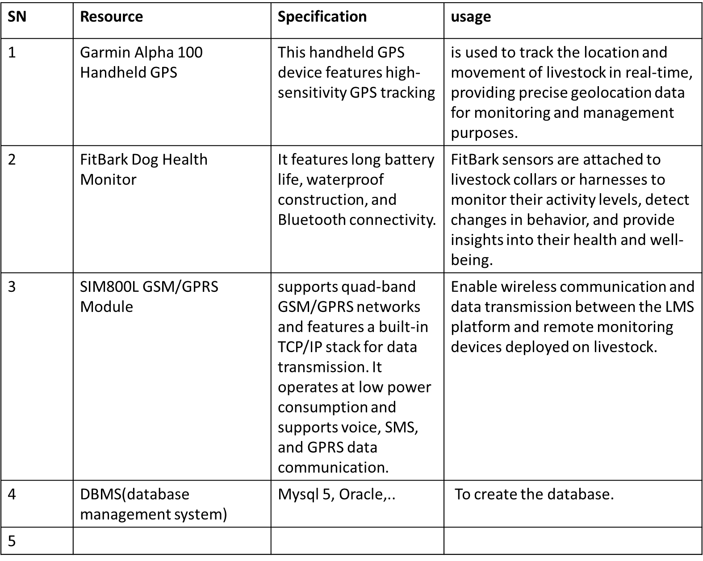

## SOFWARE RESOURCES

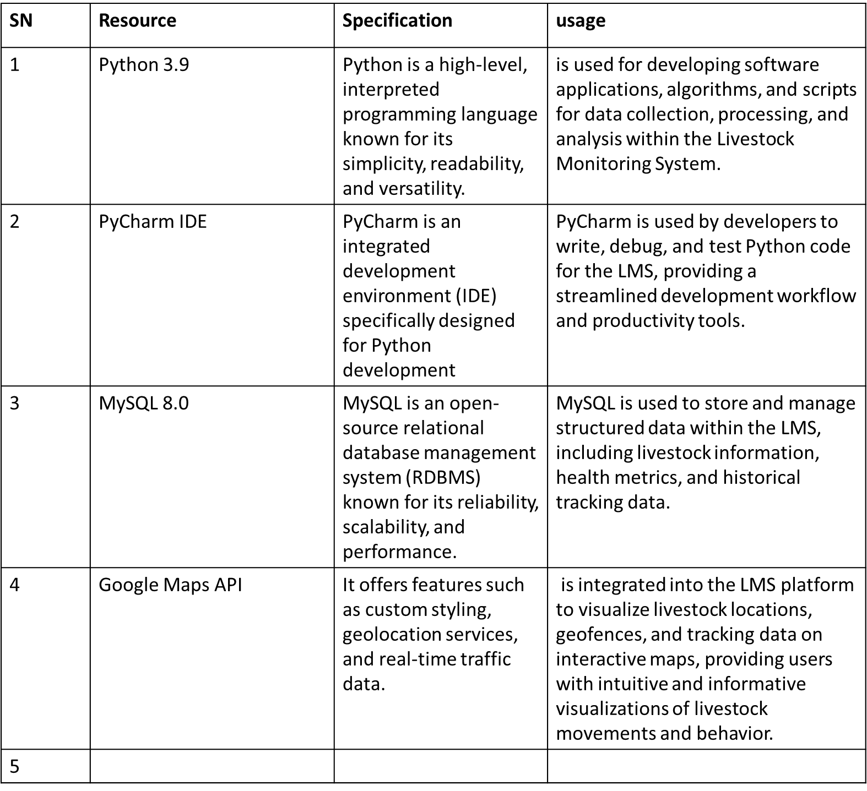

## PROJECT MANAGEMENT RESOURCES

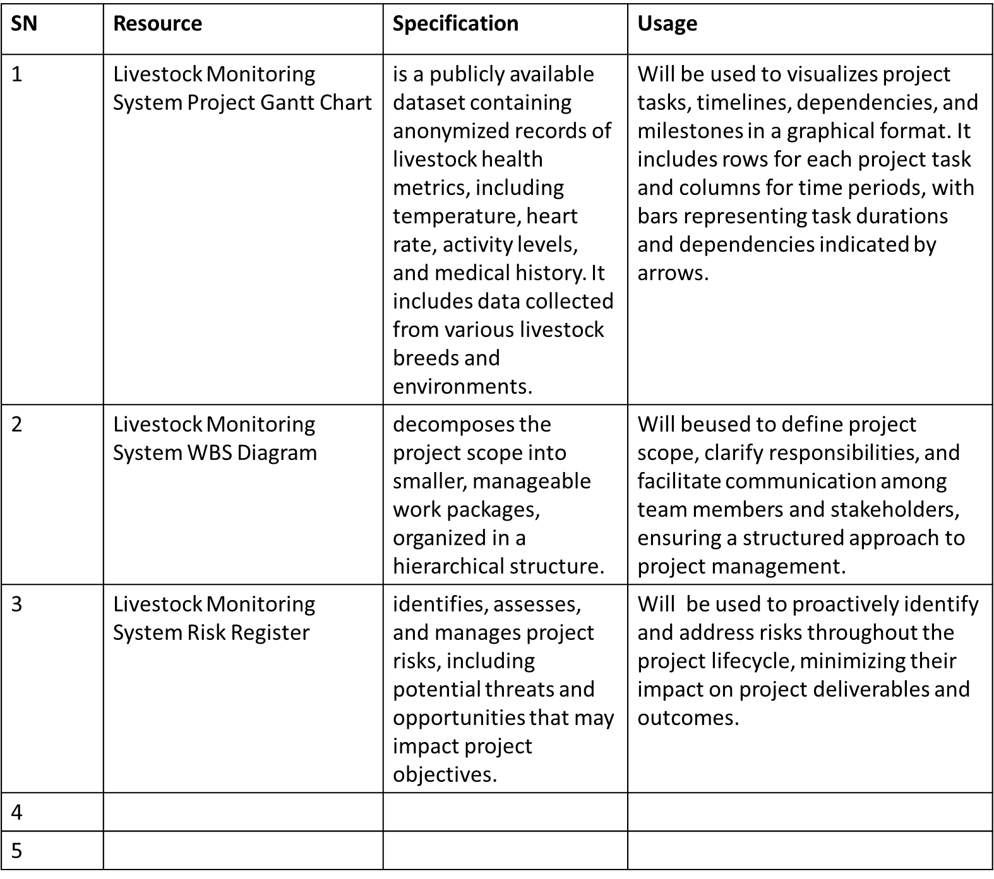

## TRAINING RESOURCES

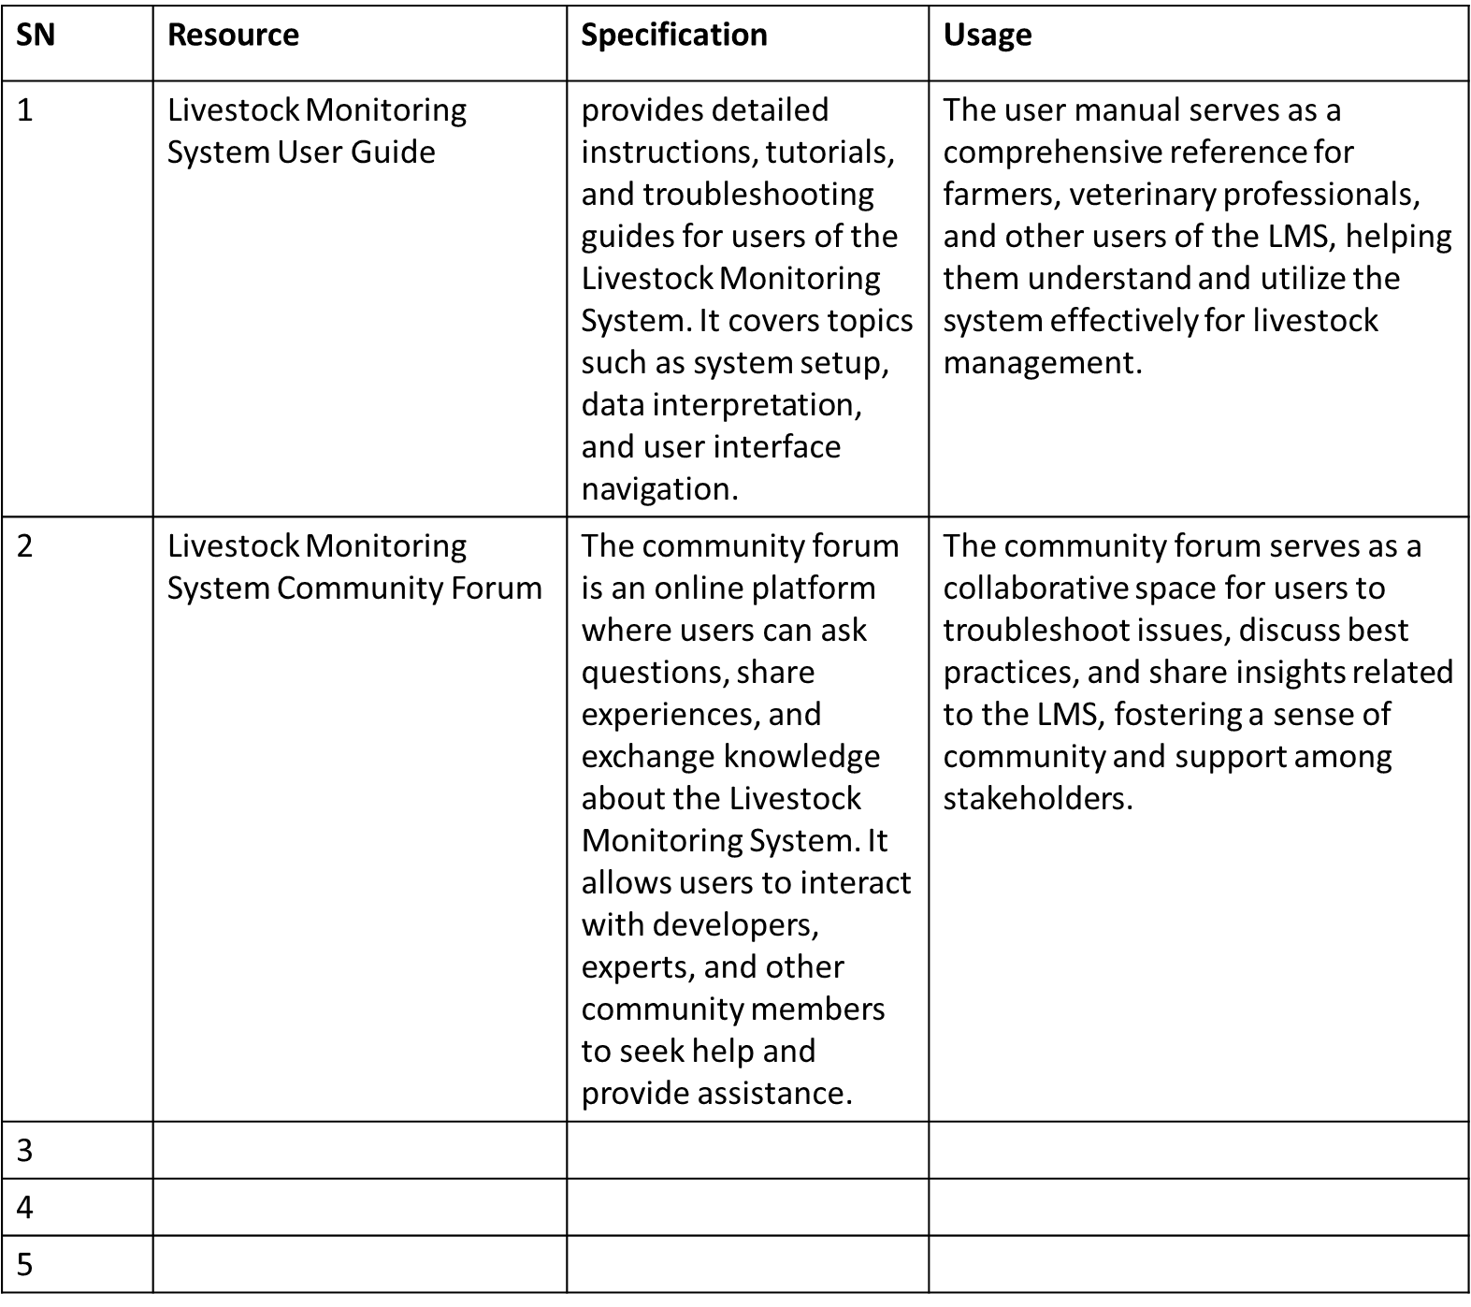

# BUDGET

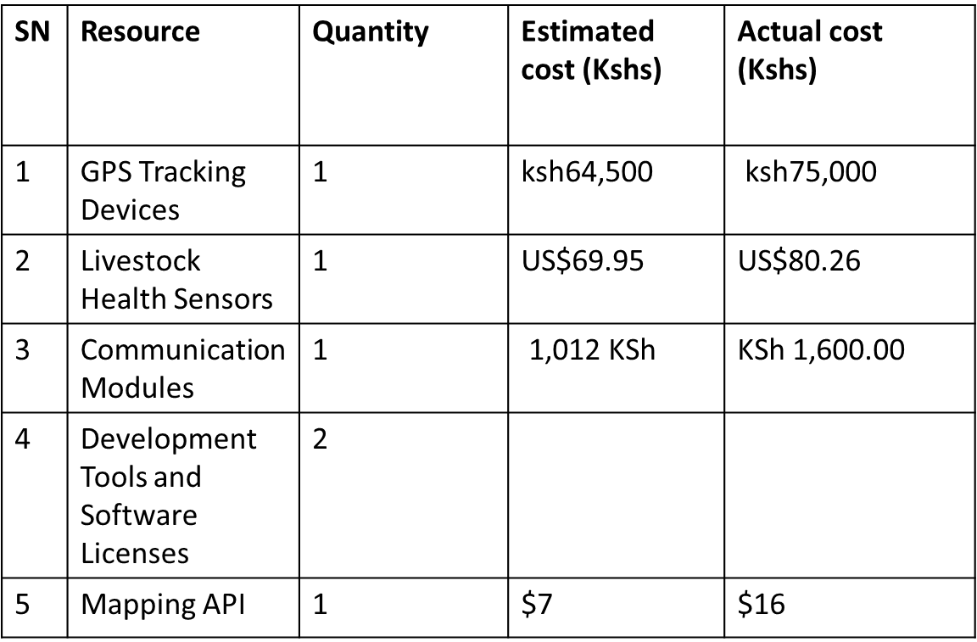

# PROJECT SCHEDULE

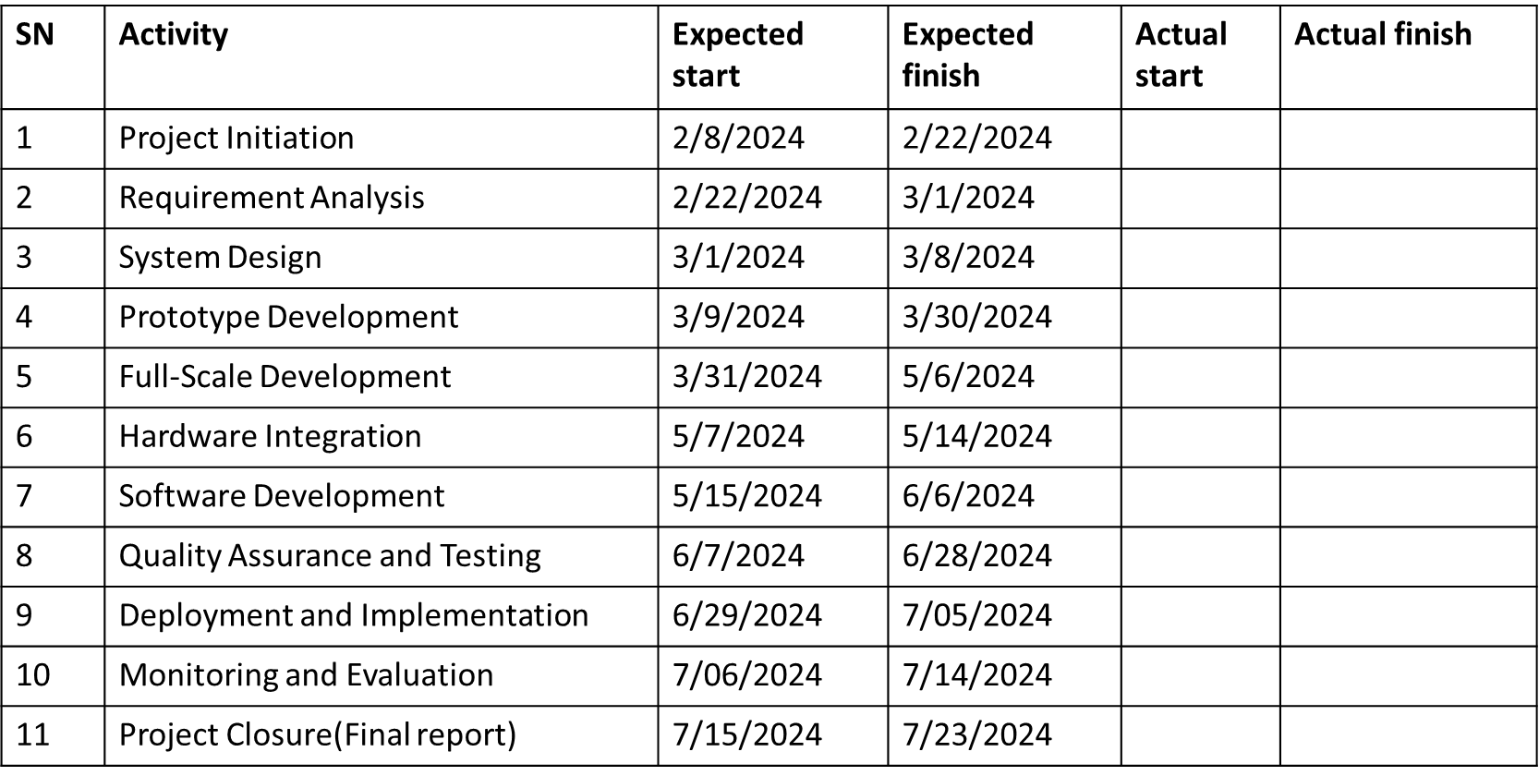

# PROJECT RISK AND MITIGATION

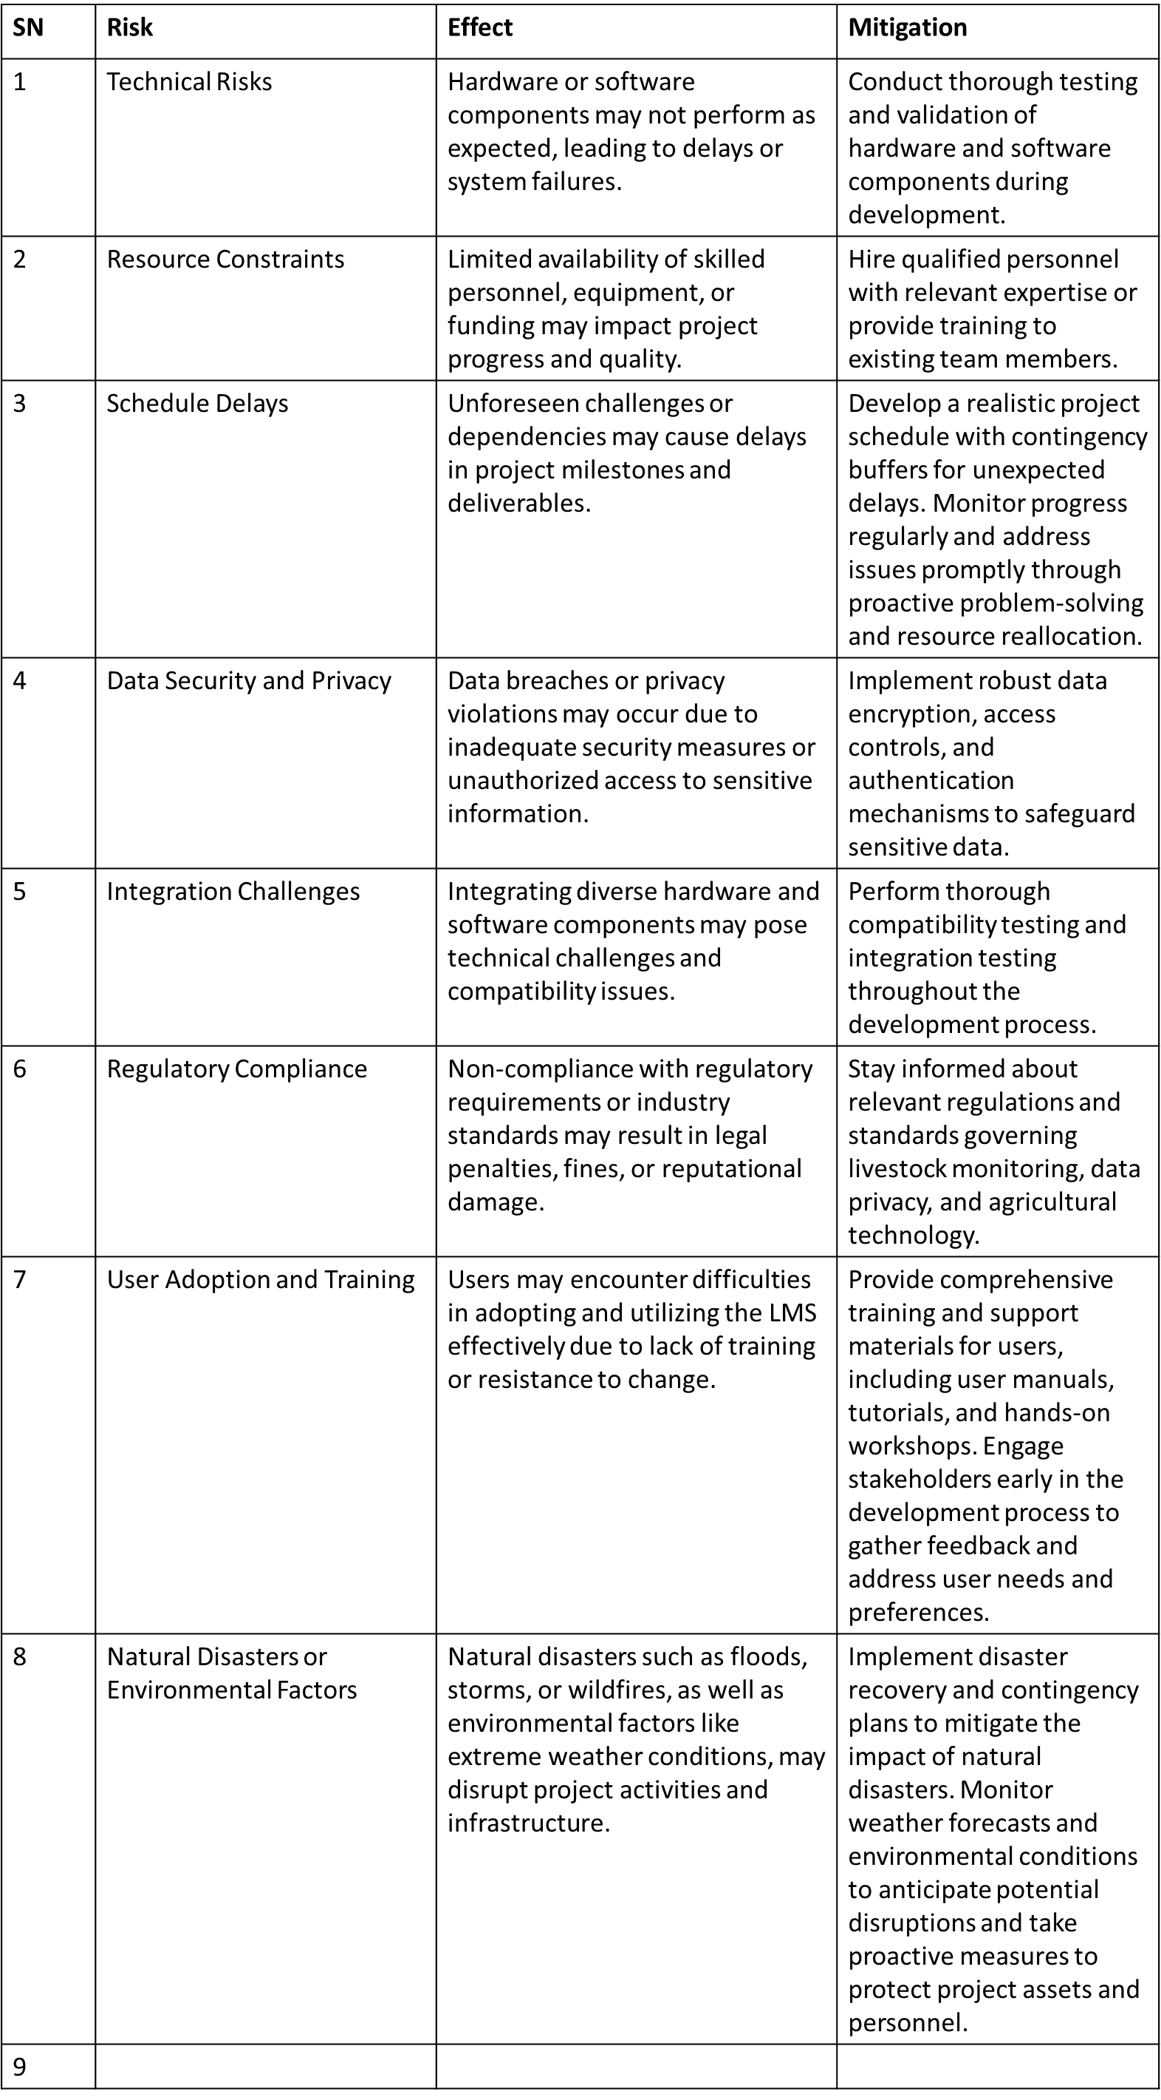

REFERENCES

Article published by By Dylan Furness and Commentary on February 8, 2018

Title**: Cattle theft in Kenya is being tackled with remote-tracking chip technology**

Link**:** [**https://qz.com/africa/1197484/climate-change-kenya-cattle-theft-tackled-with-remote-tracking-chip-technology**](https://qz.com/africa/1197484/climate-change-kenya-cattle-theft-tackled-with-remote-tracking-chip-technology)